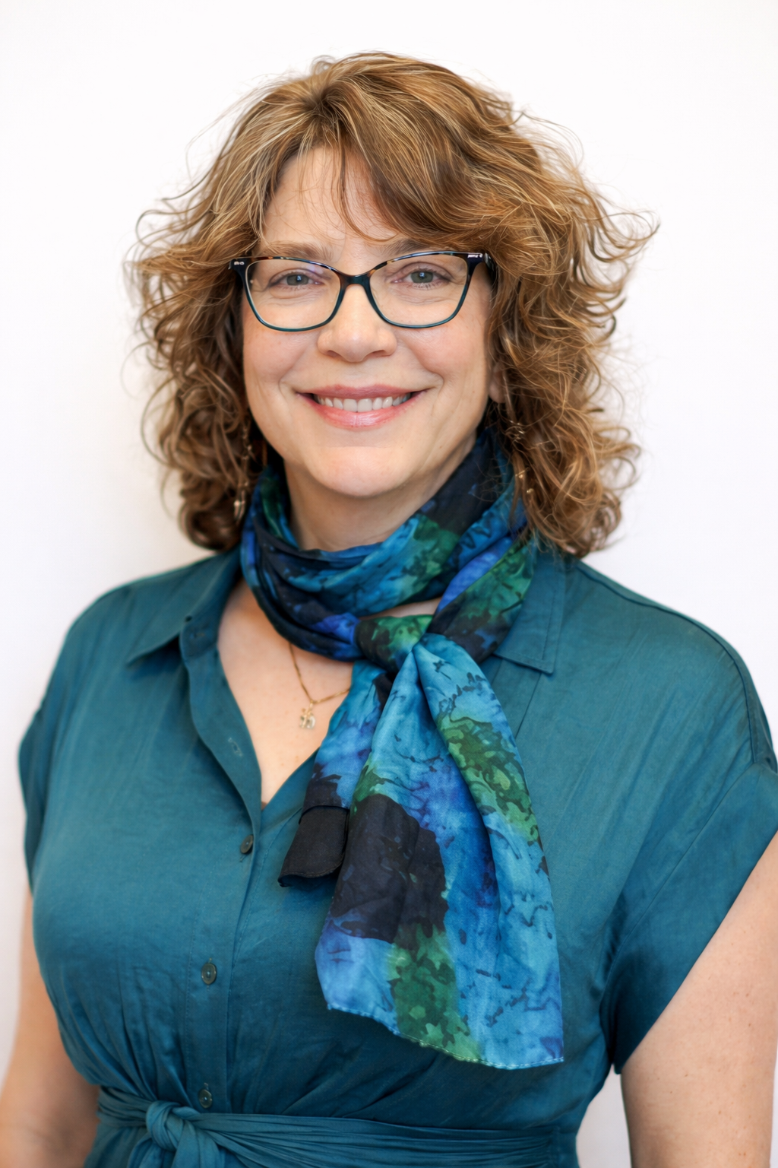
Heart-Centered Mediumship

Carol Chase, M.A. is an Evidential Medium, mentored by internationally renowned medium Joseph Shiel. She is a Certified Grief Educator, trained by world-renowned grief expert, David Kessler.

I Need a new email: MediumCarolChase@xxx.com?
I probably also need a 2nd phone number and a way to access it.
About Carol:
Our Loved Ones Are Still Here -- And They Want to Stay In Touch
I was raised with stories of relatives coming back to visit after they’d died: my uncle’s rocking chair that moved by itself, my aunt’s uneven footsteps in the hallway, a ball of blue light rising out of my great aunt’s body, circling the room, then disappearing at the moment she passed. My own first experiences of spirit visitations happened when I was a young adult when two of my grandparents visited me in dreams to say goodbye. I didn’t think it was strange, because I’d grown up with a strong belief in the afterlife, supported by these family stories and my own faith.
A number of years later, my brother-in-law Senad passed unexpectedly, and as I was sitting quietly I heard him say, “Tell your sister I’m okay. I’m FINE!” While my sister was still grieving, just two years later, the unthinkable happened to me: my beloved husband Greg crossed over after a year-long illness. And since that time, he’s been communicating with me. He has sent me messages in many creative ways that you’ll be able to read about in my forthcoming book. His body may have died, but his spirit is alive and thriving. He has shown me without a doubt that he’s still here, watching over our family with love.
After Greg passed, all that I had to do was sit, be still, and wait for the messages from Spirit. They started pouring in, and often it was with a directive to “tell Sue I’m looking out for her” or “tell Bob I’m happy he found a new wife.” Or, “Tell my mom that I’m okay.” But the spirits don’t just give messages, they come with evidential information: the tattoo on the right forearm, the corn cob pipe that’s been passed down for generations, the turtle figurine gifted from grandma just before she crossed over.
One thing is clear: our loved ones want to continue to be in relationship with us. My dream is to make that possible for everyone who wants to establish communication with their loved ones in spirit.
How I Work
As an evidential medium, I am able to receive messages from the spirit world--and provide evidence allowing clients to identify the communicator. I receive my messages by seeing, hearing, feeling, smelling, and knowing. Sometimes, I’ll even taste something that evokes a memory for the client. For example, I might say “I know I am with a man who feels like a father figure. I see him driving a red pickup, and I can feel it rolling over. I see a pack of cigarettes in his shirt pocket, and I can hear him coughing.” And then, I’ll stop to check in with my client to confirm that this is indeed her father, that he had a pickup and experienced an accident with the client as a passenger. He smoked and died of related causes. After we’ve confirmed the details, we’ll proceed with the reading, during which the spirit will provide more evidence and a message for the sitter.
A mediumship reading is always positive. That’s because the afterlife really is better, and as spirits, we have the opportunity to work through the mistakes we made during our lives. The afterlife provides a safe space for spirits to learn and evolve. At least, that’s what the spirits tell me! As a certified Grief Educator, I have been trained to approach every client using trauma-informed practices. ​The goal of each session is to offer validation, comfort, and peace — knowing that love and life continue even when our physical bodies no longer exist.
Finally, I work strictly with the Light, and am inspired to bring peace and love to all who want to receive a reading, both in this world and the next.

What is a Certified Grief Educator?
Grief is profound and often lonely. We live in a grief-illiterate society. People don't need someone to fix them—they need a guide and companion. Someone who understands that loss changes us, and that we can honor our loved ones while creating a new chapter. I'm here to witness your experience, help you understand what you're feeling, and support you as you find your way forward. I work with people one-on-one, in groups, or online—whatever serves them best.
A Certified Grief Educator is committed to providing the highest level of grief support through education, experience, and insights into the often unacknowledged rocky terrain of grief.
I have completed a Certified Grief Educator certificate program designed by world-renowned grief expert, David Kessler. I bring his unique methodology, tools, and decades of experience to help people navigate the challenges of grief.
Teachers: Rev. Joe Shiel, David Kessler, Simone Key.



TESTIMONIALS
Dear Carol,
Thank you very much for your Wonderful and
Amazing Evidential Mediumship Reading.
You were Spot-On! Your reading brought me
happiness, comfort and healing. 
Carolyn H.

Carol is an AMAZING medium! She is very kind, warm, welcoming, and thoughtful. The way she initiated the reading that she did for me was performed with such a delicate, gracious, and heartfelt approach. I had a dear friend of mine commit suicide about a year ago which struck my soul in ways I could not even comprehend, making it so much harder to imagine receiving closure as a possibility; but, then Carol brought that kind of loss into life. She made it possible for me to connect with my friend again, and the closure was as clear as day. I was in tears! Her ability to build a bridge into the spiritual realm is beyond profound. What felt so lost and intangible for me was then finally found. She is a true gift! Thank you Carol!
Felicia L.

Carol is very friendly and professional, creating a safe and loving space. Great energy! I love that she brought in my grandparents together. The sewing references were spot on!
Charlene H

Carol, thank you so much for connecting me with my beloved mother today. I had no doubt that she was present with us. Your perception of her putting on red lipstick was particularly meaningful to me. One of my strongest memories of my childhood is of watching her getting dressed up to go dancing with my father and putting on red lipstick! So that evidence was very special for me. Thank you, too, for the extensive messages you relayed to me from her. It was as if she were talking directly to me, as everything you expressed is what she advised me, my siblings, and others in life.
Karen V.

Book a Mediumship Reading with Carol
Evidential Mediumship Readings

For the most authentic experience, I ask that you do not share any personal information or details about yourself or the person you wish to connect with beforehand. Evidence of Spirit’s presence and communication will arise naturally during the sitting, directly from those in the next world.

Mediumship Reading — 30 Minutes
A 30 mn mediumship reading on Zoom
30 min
30 min
75 US dollars
$75
Remotely - over phone or zoom
Book Now

Service Description
Thank you for reaching out! I'm Carol, an Evidential Medium mentored by internationally renowned medium Joseph Shiel. This is not a psychic reading, but an evidential connection with Spirit.

In our 30-min or 60-minute live Zoom session, I bring through clear details to help you recognize your spirit communicator/s. I will tell you exactly what I see, feel, hear, or experience in order to allow the spirit to provide their own identifying evidence.

I do not ask for the name of the person you hope to hear from. I also cannot guarantee a specific loved one will come through. Spirit people who do step forward always come for your highest and best good. I recommend you take notes or audio-record the reading, because some details may make sense later.

I will always treat you and those in spirit with compassion and respect. Messages are supportive and positive. During the evidential portion, please respond only with "Yes", "No", "I don't know", or "I'm not sure" or "Need more info".

Each reading reserves time at the end for feedback. I can’t wait to work with you!

Cancellation Policy
Cancellation Policy: If you need to cancel your appointment for any reason, you must do so at least 24 hours before your appointment time in order to receive a full refund or reschedule your session. Cancellations made within fewer than 24 hours of your appointment will not receive a refund.Cancellations/rescheduling must be done in writing via email. If you are more than 10 minutes late, your appointment is considered a no-show, and no refund or reschedule will be given.

Contact Details
phone
email
Delaware County, PA, USA

​
Please note that this is not a psychic reading. Mediumship focuses on connecting with loved ones in Spirit rather than predicting future events or giving life advice. Every session unfolds naturally according to the needs of Spirit and the sitter.

Evidential Mediumship Reading - 30 minutes $75
50 minutes $150

